

7:30 Best Practices Presentation

8:15 Peg Norris – Beautification Committee Applicant
Bob Norris– Beautification Committee Applicant

Old Business

- 2012 Annual Town Election Date

New Business

- One Day License Requests

- Road Race Request

- Cell Tower Bid

Executive Session

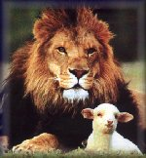

In Like a Lion Out Like a Lamb

